Trouble Shooting and Input Validation

# Trouble Shooting:

## Close App button does not work:

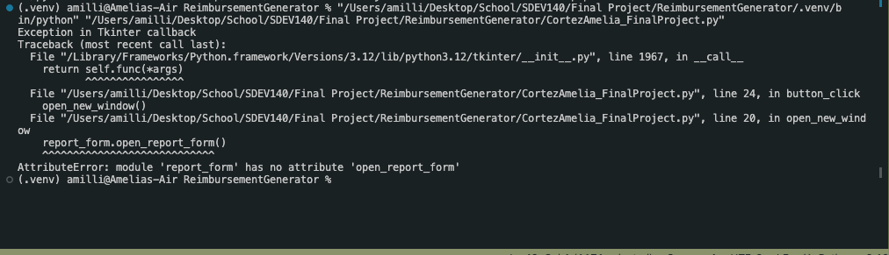

Work around:

Taking the report_form.py code and restructuring it into a class helped solve this problem.

## If no new window is open and you click close app button, it calls and opens the report_form.py

Work Around:

Taking the report_form.py code and restructuring it into a class and then restructuring the call of class as a top level in the main window script fixed this problem.

# Input Validation

Data Set 1:

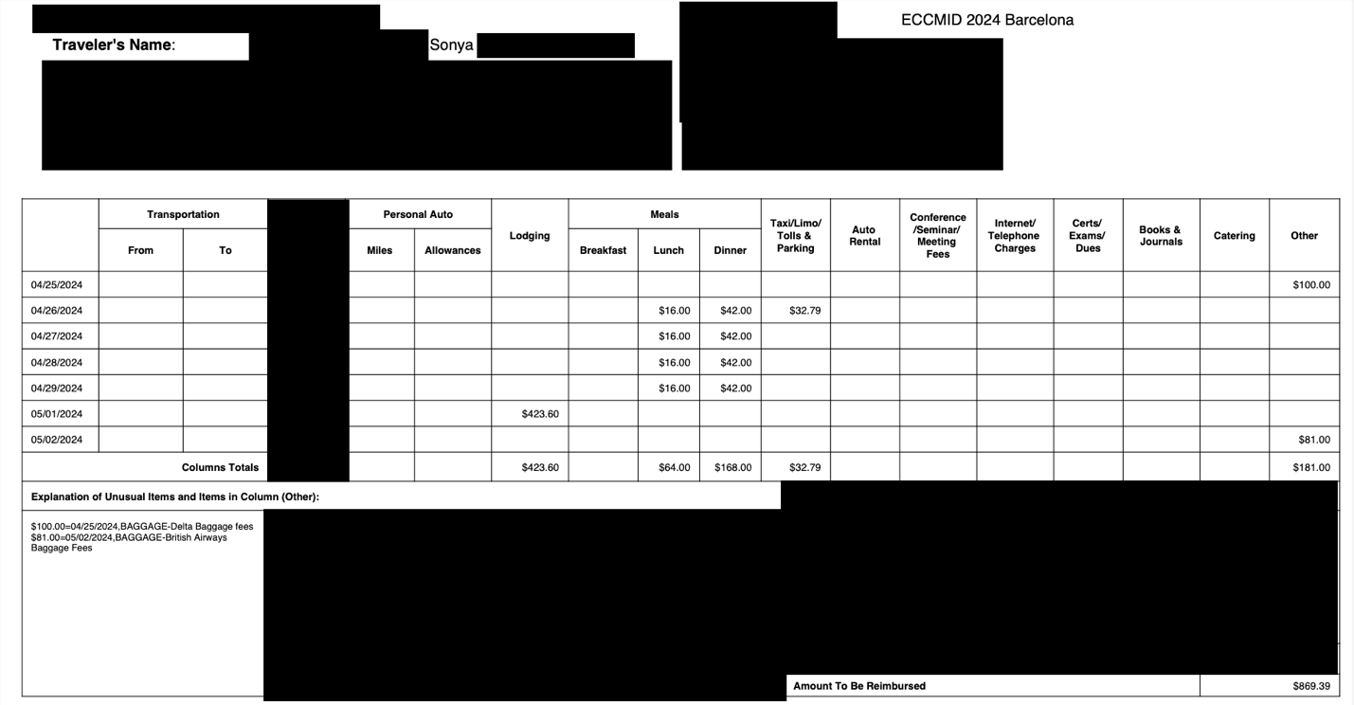

* Ran program no issues but did not like how file name looked and extra rows on template:

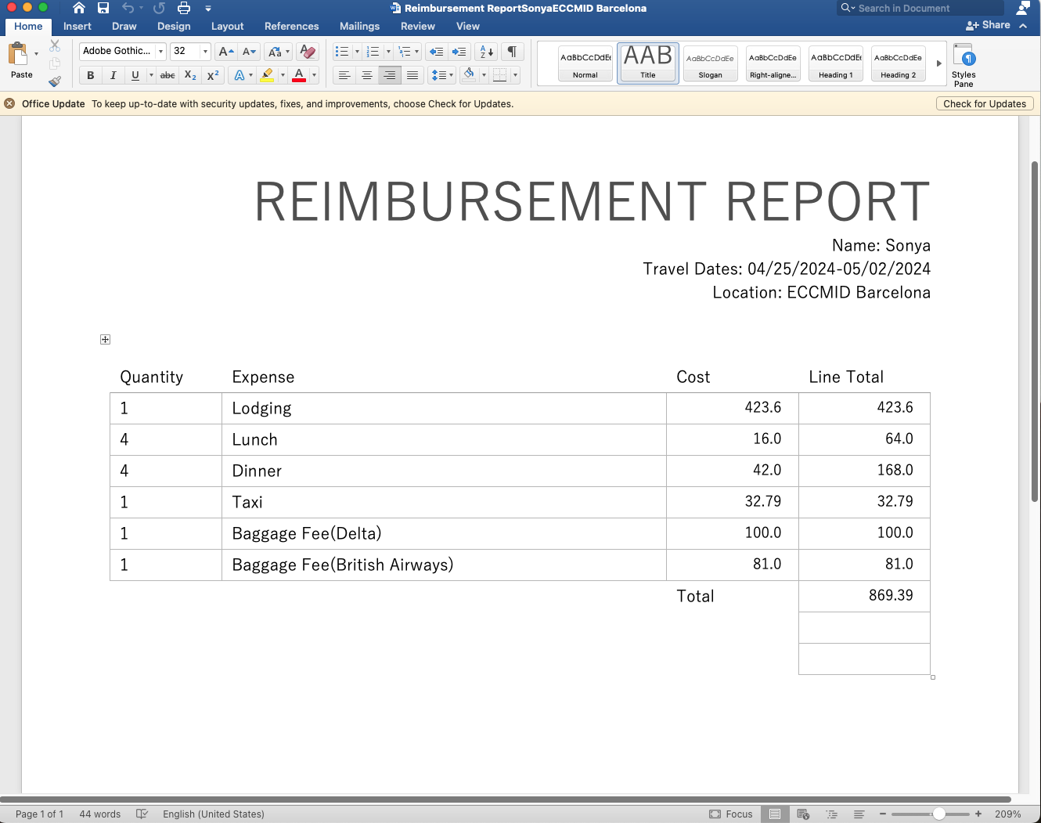

* Fixed Code to save file in better format and removed extra rows from template:



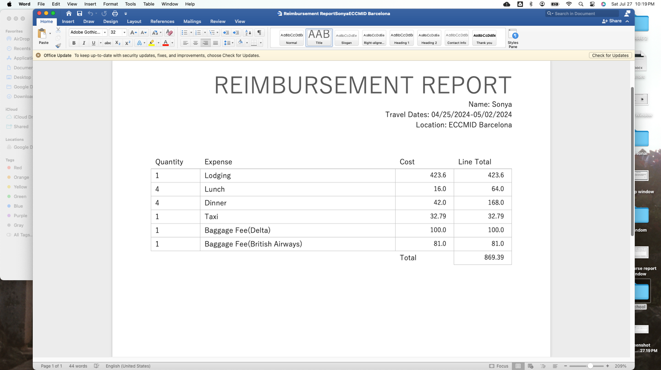

Data Set 2:

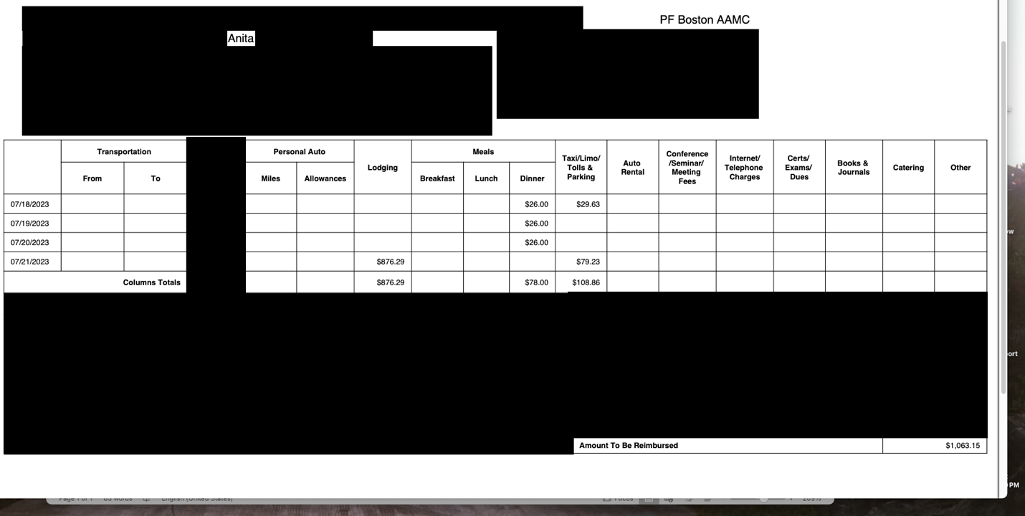

When report was created total looked like this:  
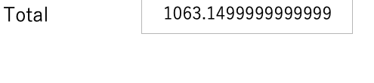

Changed the appropriate code lines to round to the nearest 100th:





Fixed report total line:

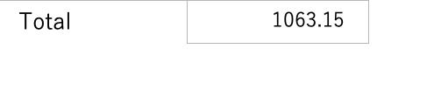

Data Set 3:

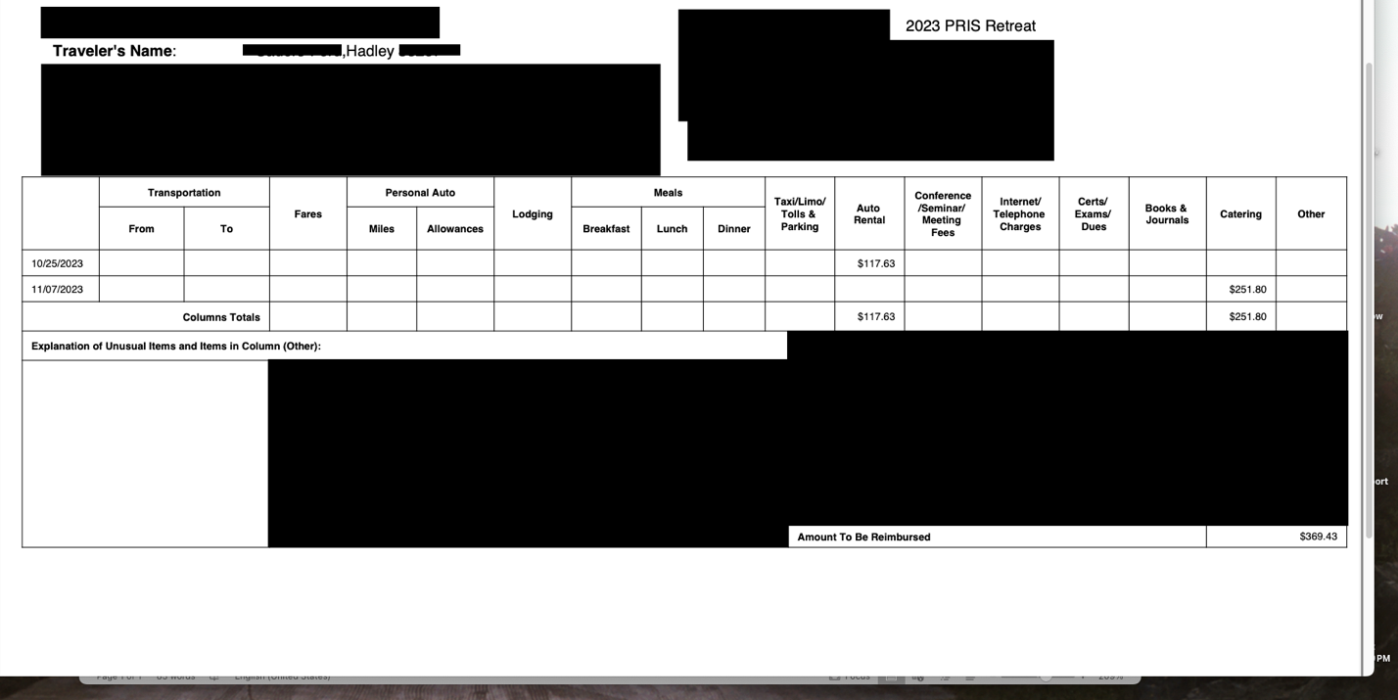

Program Ran successful:

